# 1.INTRODUCTION

# 1.1 Over view

This report delves into the captivating realm of India's agricultural cultivation,providing a comprehensive visual exploration of key aspects and trends in the agricultural sector. Through the visual representations, readers can gain valuable insights into crop production, seasonal variations, regional distribution, and overall production trends. These visualizations enable intuitive analysis, allowing stakeholders to uncover patterns, identify areas of growth or concern, and make data-driven decisions.

By harnessing the power of Tableau, this report not only presents the data in a visually appealing manner but also provides an interactive experience for readers to explore the intricacies of India's agricultural cultivation. To Extract the Insights from the data and put the data in the form of visualizations, Dashboards and Story we employed Tableau tool.

# 1.2 Purpose

* Crop production is a common agricultural practice followed by worldwide farmers to grow and produce crops to use as food and fibre. This practice includes all the feed sources that are required to maintain and produce crops
* Crop production is the basis for providing the livestock industry with feed, and the population with food. Also, crop products are used in many industries as raw materials of plant origin, such as food, textile, pharmaceutical, fuel and others.
* Multiple cropping can increase production and income and has additional benefits—increased crop diversity, improved functioning of agricultural systems, spare land for biodiversity or other uses and reduced use of inorganic fertilizer and pesticides.

# 2 Problem Definition & Design Thinking

## 2.1 Empathy Map

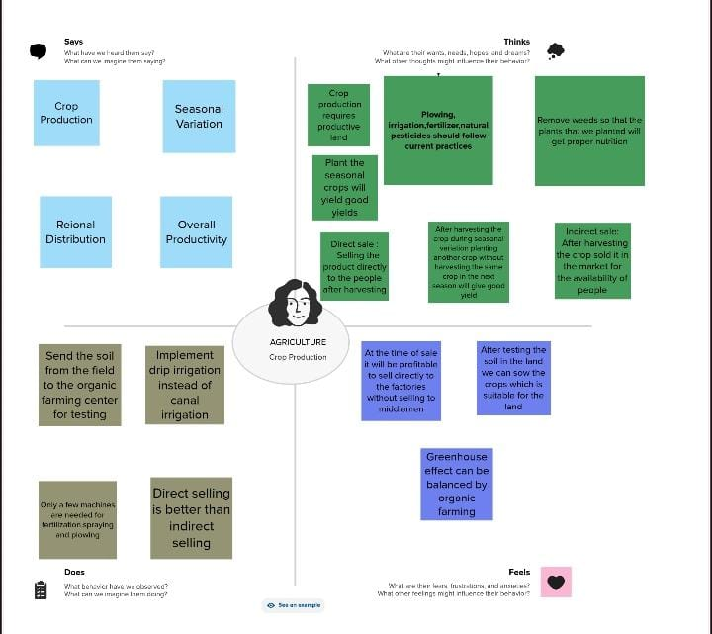

# 2.2 Ideation & Brainstorming Map

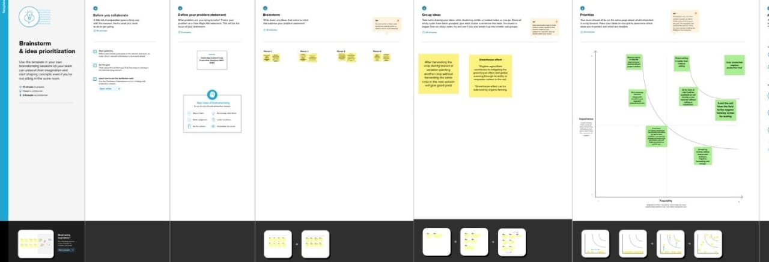

# 3 .RESULT

## 3.1 Dashboard

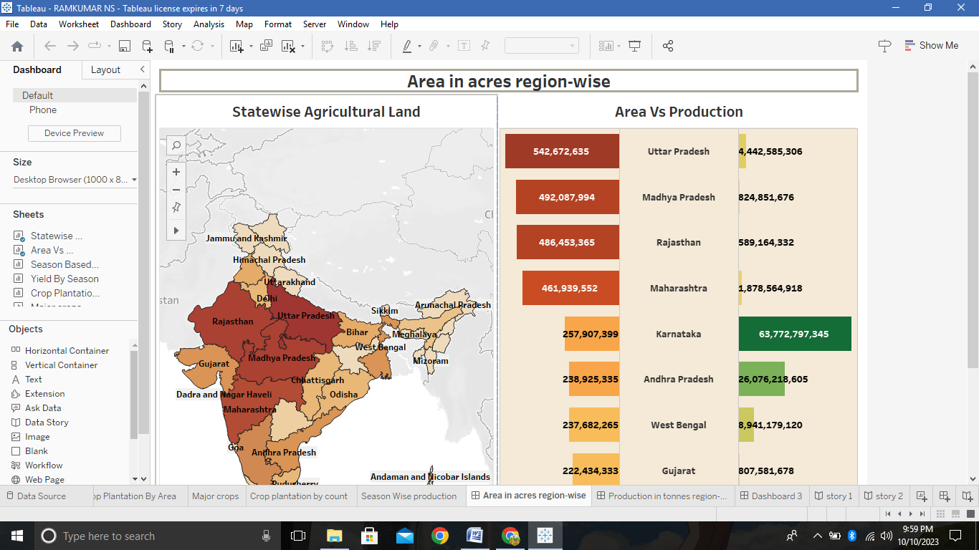

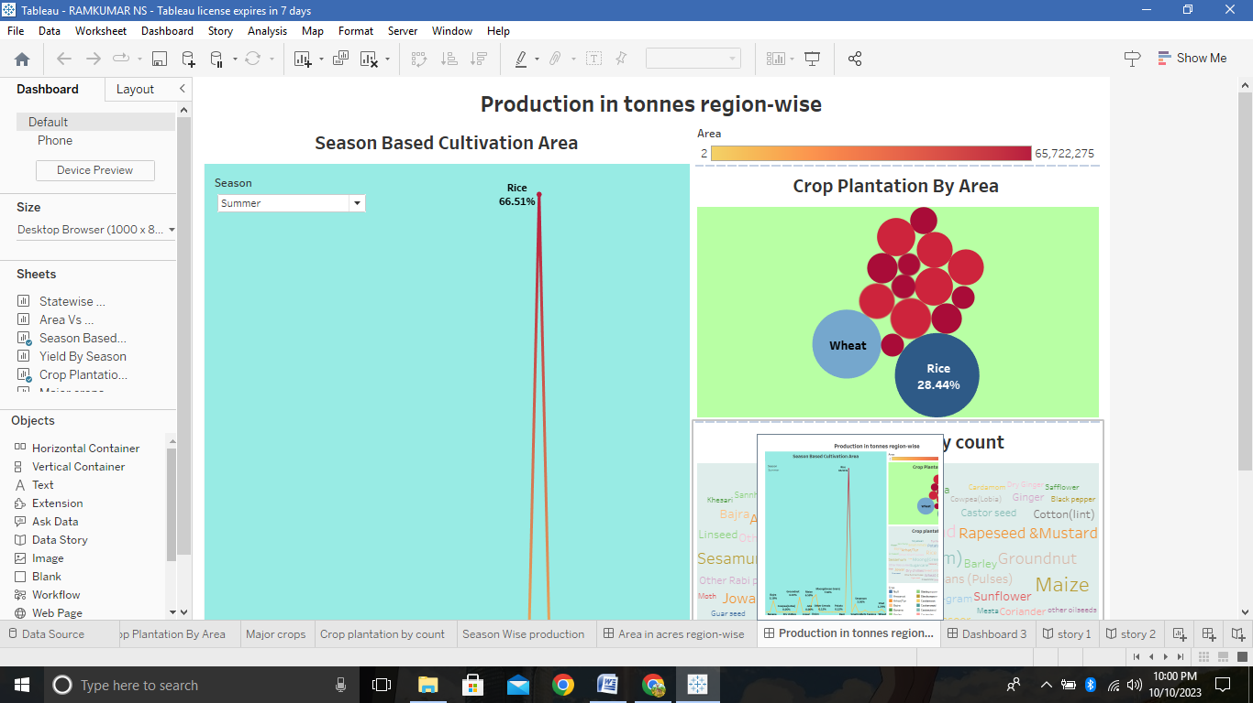

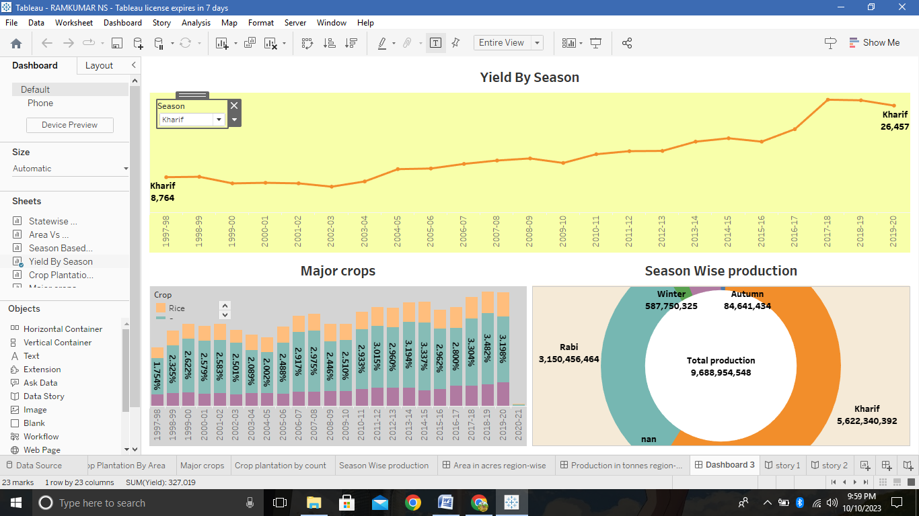

# 3.2 STORY

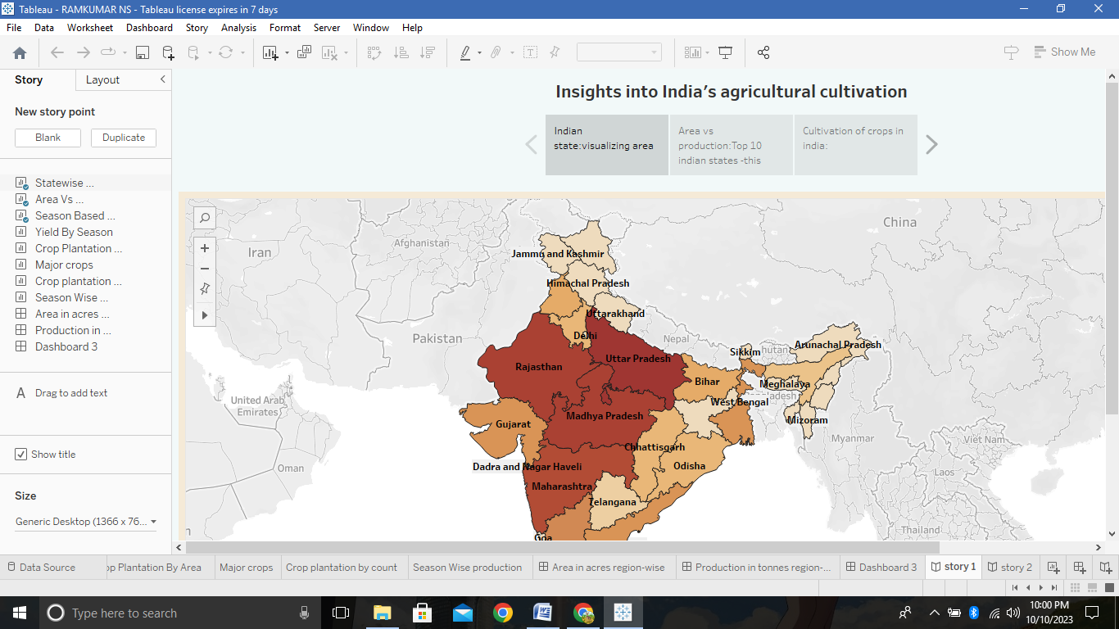

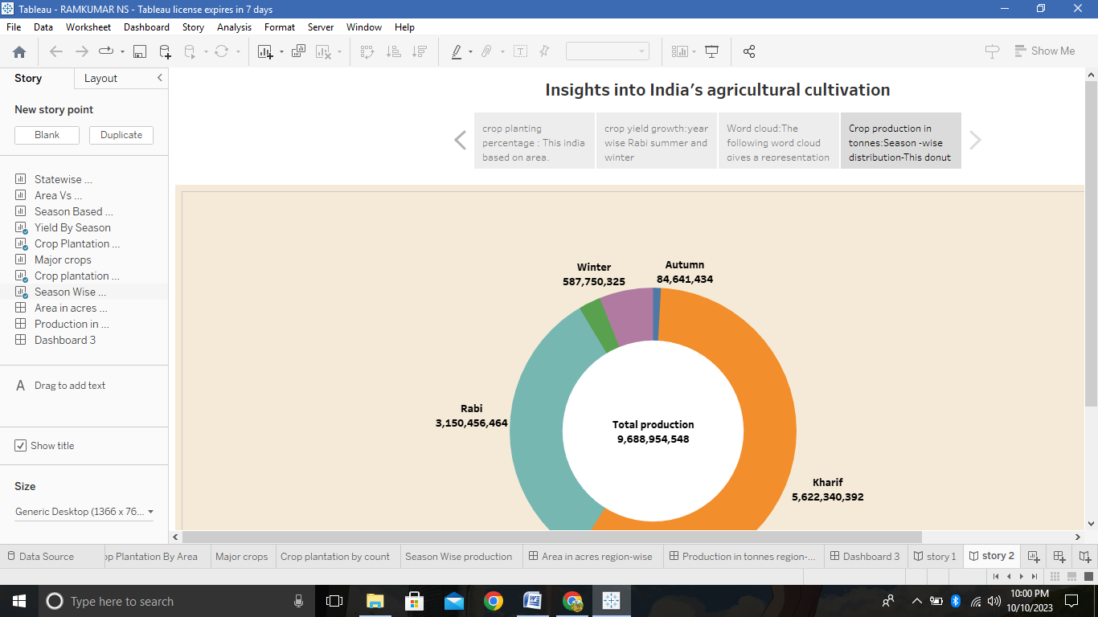

# 4.Advantages & disadvantages

## Advantages

* There is over all increase in yield of crops mainly due to maintaining physical – chemical properties of soil.
* It helps in controlling insects, pests and soil borne diseases.
* Prevent on limit periods of peak requirement of irrigation water.

## Disadvantages

* Pest and weeal resistance to chemicals.
* Soil degradation.
* Impact on natural habitats.
* Water pollution.
* Climate change.
* There is no insurance against crop fail.

# 5.Applications

* Mapping ,Monitoring and managing farming decisions precisely.
* crop production is important for food security the economy and the environment .
* Remote sensing gives the soil moisture data and helps in determining the quantity of moisture in the soil and hence the type of crop that can be grown in the soil.

# 6.Conclusion

* The Indian economy is an agro-economy and depends highly on the agricultural sector.
* plantation agriculture has a long and complex history. It is a vital part of the global food system, and has been an important source of income and employment for many people.

# 7.Future scope

* Future Crops is an agtech company that uses technology and agricultural expertise to grow crops in a fully controlled environment.
* There will be more of vertical and urban farming and there will ales be efforts in long term to find new areas for production Like barren deserts and seawater.
* Agriculture sector is the largest sector with 49% of country's population works Agriculture sector by occupation.